**Lab 6 Assignment**

**Working with DOCKER**

**Aim:** Create a customized docker image and perform the following

1. **Create Docker File by own.**

ARG PYTHON_VERSION=3.11.7

FROM python:${PYTHON_VERSION}-slim as base

ENV PYTHONDONTWRITEBYTECODE=1

ENV PYTHONUNBUFFERED=1

WORKDIR /app

ARG UID=10001

RUN adduser \

    --disabled-password \

    --gecos "" \

    --home "/nonexistent" \

    --shell "/sbin/nologin" \

    --no-create-home \

    --uid "${UID}" \

    appuser

RUN --mount=type=cache,target=/root/.cache/pip \

    --mount=type=bind,source=requirements.txt,target=requirements.txt \

    python -m pip install -r requirements.txt

USER appuser

COPY . .

EXPOSE 8000

CMD python app.py

1. **Get the latest python image from Docker Repository.**

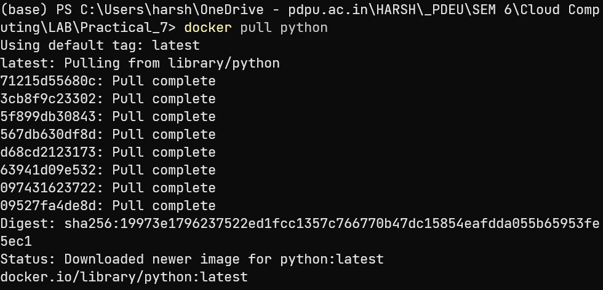

1. **Write down a simple python program or get it from internet.**

def fibonacci(*n*):

    a, b = 0, 1

    for _ in range(n):

        print(a, *end*=" ")

        a, b = b, a + b

fibonacci(10)

1. **Run Python Program inside the Container.**

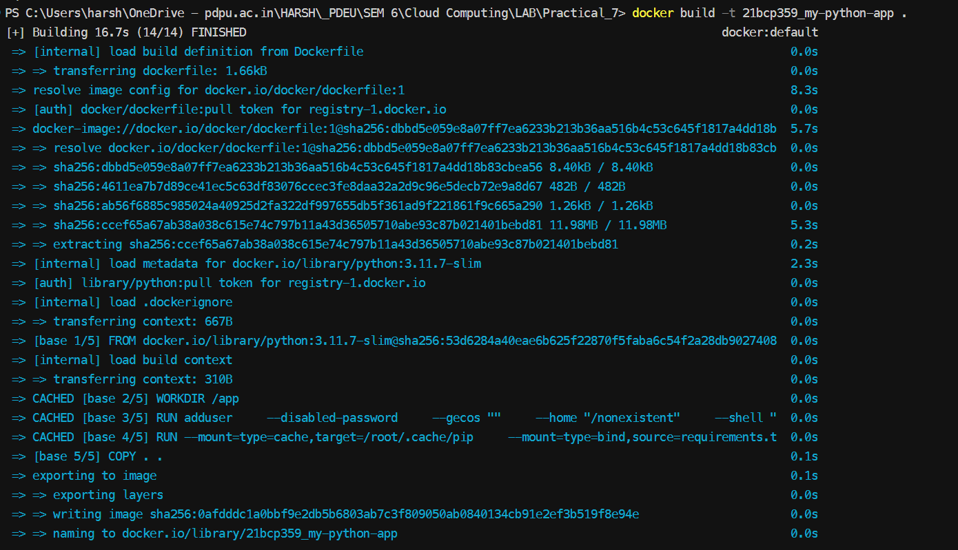



1. **Tag and Push the Image to Docker Hub.**

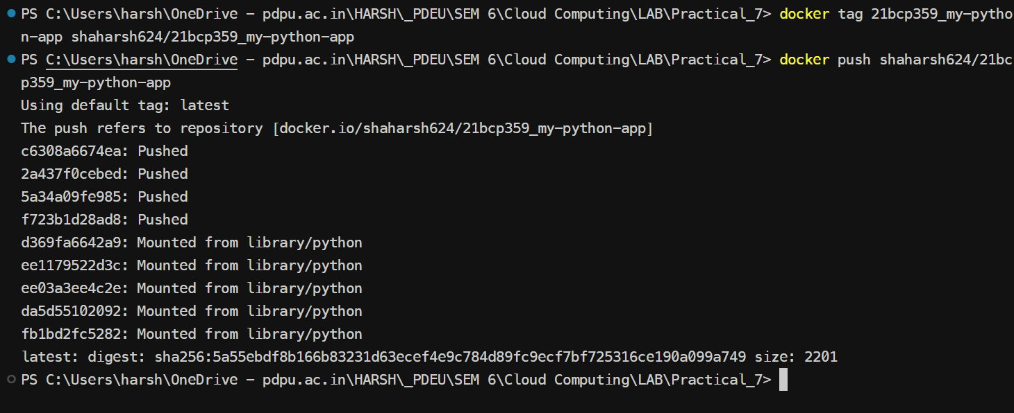

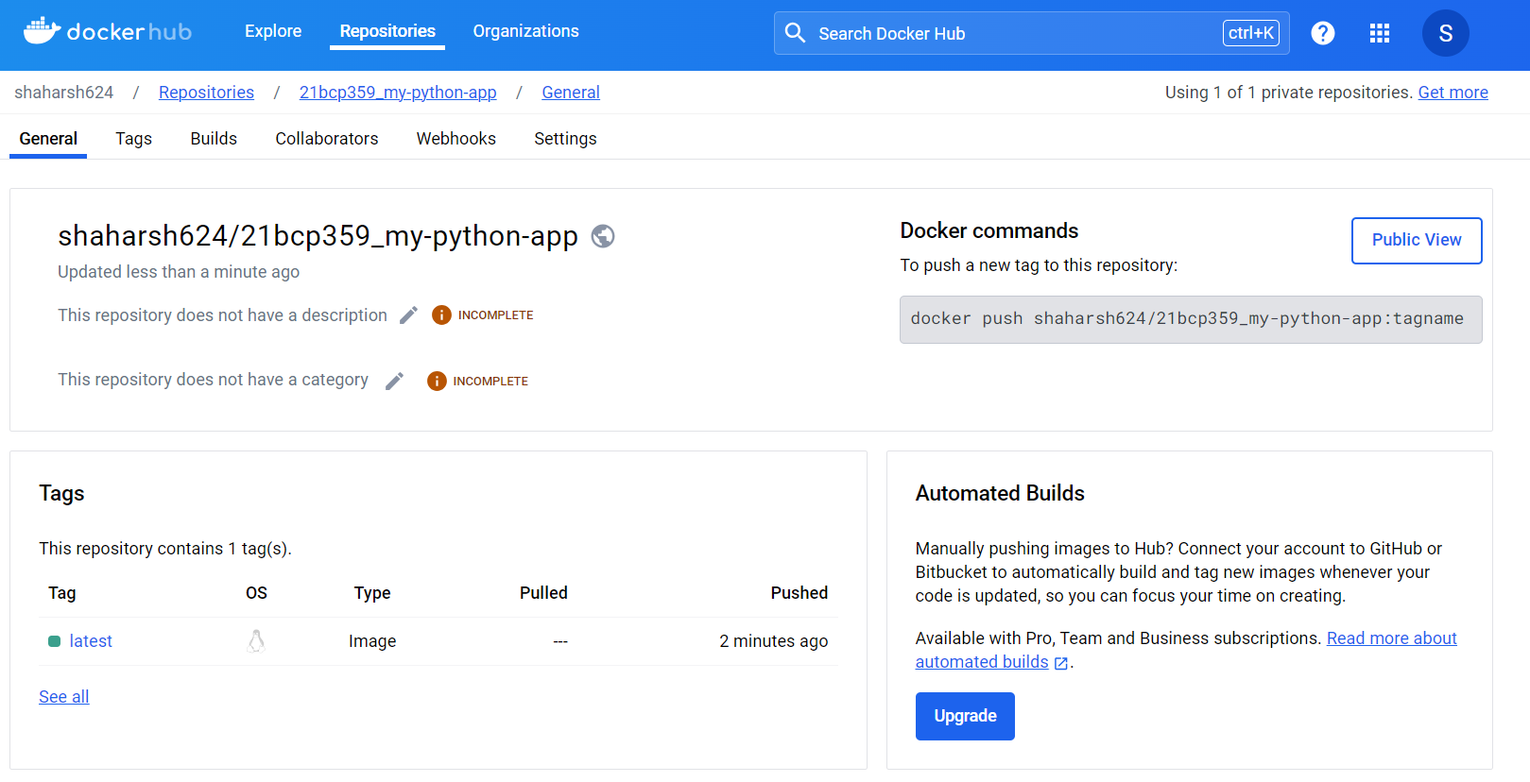

1. **Remove Image from Local and Again execute it from Hub.**

